Data base management related to album project
At the bagening of the album project a data base was set up. As the project became important I was hard to maintain code. It was time consuming. As a mater of fact at the begining a data base management was thought but due limited space, environment th most important was to design it, code it.
Now it can be built because project is kinda stable.

The foundations
The data base consist of colomun and lines.

Here is a draft of the bnf definition of the data base:

DataBase::=ColumnName EOL (ColumnValue |
(ColumnValue EOL)*
)

ColumnName::=(Name ColumnSeprator)* Name

ColumnValue::=(Value ColumnSeparator)* Value

Name::=[a-zA-Z][a-zA-Z0-9 ]+

Value::=[a-zA-Z0-9]+

EOL::= ('\r' '\n' )| '\n'

ColumnDSeparator::= '||'

And this is the rail road diagram associated:

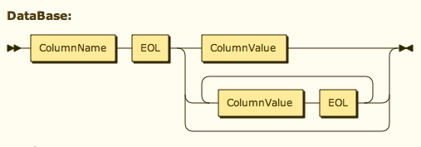
Rail road diagram associated to bnf

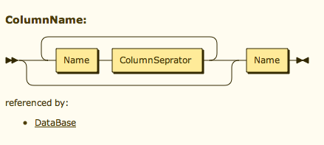

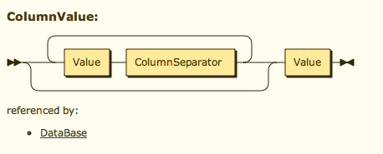

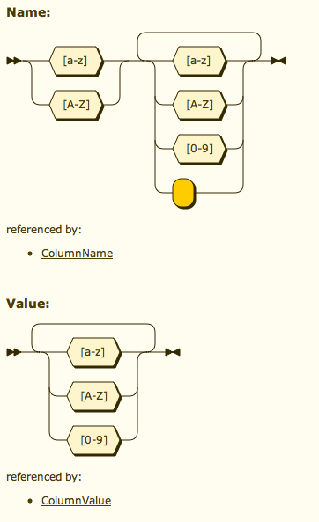

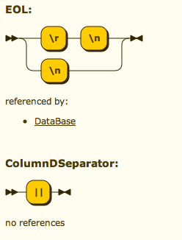

Ressources:
to make rail road drawings: http://railroad.my28msec.com/rr/ui

